1. A = {1,2,3,4,5,6,7}   
   B = {4,5,6,7,8,9}

Domain = {1,3,4,7}

Range = {4,5,6,7}

R = {(1,5),(4,5),(1,4),(4,6),(3,7),(7,6)}

R-1= {(5,1),(5,4),(4,1),(6,4),(7,3),(6,7)}

1. A = {1,2,3,4}

B = {1,3,5}

R = {(1,3),(1,5),(2,3),(2,5),(3,5),(4,5)}

R-1 = {(3,1),(5,1),(3,2),(5,2),(5,3),(5,4)}

1. C = {2,3,4,5}

D = {3,6,7,10}

R = {(2,6),(2,10),(3,3),(3,6),(5,10)}

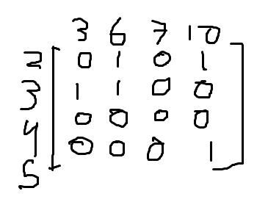

R-1 = {(6,2),(10,2),(3,3),(6,3),(10,5)}

1. R1 = transitif

R2 = bukan refleksif,simetris, dan transitif

R3 = bukan refleksif,simetris, dan transitif

R4 = refleksif, dan simetris